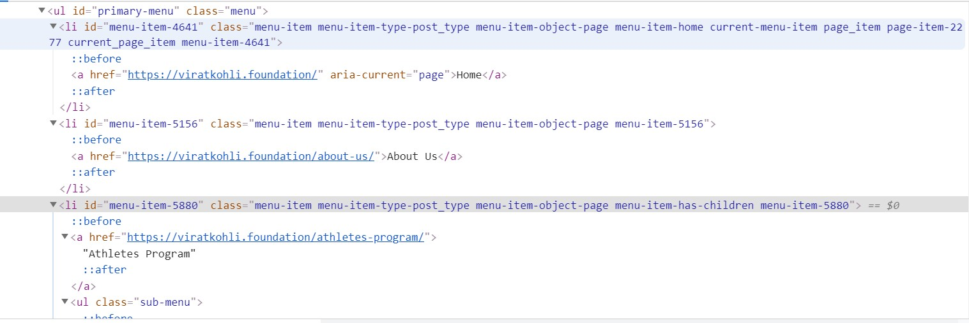

Please see above html code snippet and write xpath as below:
- Atleast 3 Xpath’s for ‘Atheletes Program’
- //a[contains(text(),'Athletes Program')]
- //li[@id='menu-item-5880']/a[contains(text(),'Athletes Program')]
- //li[@id='menu-item-5880']/child::a
- //li[@id='menu-item-5880']/child::a/ancestor::ul/child::li/following-sibling::li[2]//child::a
- //ul[@class='sub-menu']/preceding-sibling::a

- Atleast 3 Xpath’s for ‘About Us’ , one of them using primary menu as id
- //a[contains(text(),'About Us')]
- //li[@id='menu-item-5156']/a[contains(text(),'About Us')]
- //li[@id='menu-item-5156']/child::a
- //ul[@id='primary-menu']/child::li[2]/
- //ul[@id='primary-menu']/child::li[2]/child::a
- //ul[@id='primary-menu']/child::li//following-sibling::li/child::a

- li (list) tag with menu-item-5156
- //li[@id='menu-item-5156']/child::a/parent::li
- //li[@id='menu-item-5880']/parent::ul/child::li[2]
- //li[@id='menu-item-5880']/../li[2]
- //ul/li[@id='menu-item-5156']

- About us xpath using text method
- //a[contains(text(),'About Us')]
- //li[@id='menu-item-5156']/a[contains(text(),'About Us')]
- //li/a[contains(text(),'About Us')]

